# **Loan Application Technical Design Document**

Navakethan Gajams

Department of Information Technology, Arizona State University

IFT 598: Middleware Programming and Database Security

Dinesh Sthapit

December 03, 2022

**1. Introduction**

**1.1 Purpose**

The purpose of this document is to outline the technical design of the Loan Application.

Its main purpose is to -

Detail the functionality which will be provided by each component or group of components and show how the various components interact in the design.

As is true with any high-level design, this document will be updated and refined based on changing requirements.

**1.2 Design Organization**

This document is organized into the following sections:

|  |  |
| --- | --- |
| Introduction | Provides information related to this document (e.g., purpose, term definitions etc.) |
| Design Overview | Describes the architectural goals, and constraints,  technologies used in design and development |
| Flowchart Diagram | Describes the various system components and the integration between  them |
| Application Architecture | Describe the application architecture in terms of different screens. |
| Database Architecture | Describes the overall Data model for the loan application |
| Assumptions and  Constraints | Details various assumptions made during design and development of the  Loan application |
| Future Enhancements | List of features which can be implemented |

**2. Design Overview**

**2.1 Architectural Goals and Constraints**

The overall architectural goal of the system is to highly scalable loan application which is used for tracking of the various loans created.

The loan application has the below features:

* Allow users to sign up to create a new user account.
* Ability of users to login into the application using login page.
* To present the user with all the list of the loans available in the Mongo DB atlas database.
* Allow users to export the list of loans to excel.

**2.2 Technologies used**

The loan application is developed using the below technologies:

* Front-end (User interface): The UI of the application is developed using pug, bootstrap, CSS, JavaScript, and jQuery.
* Middleware: Express.js and Node.js.
* Backend: MongoDB atlas is used to store the data.

**3. Flowchart diagram:**

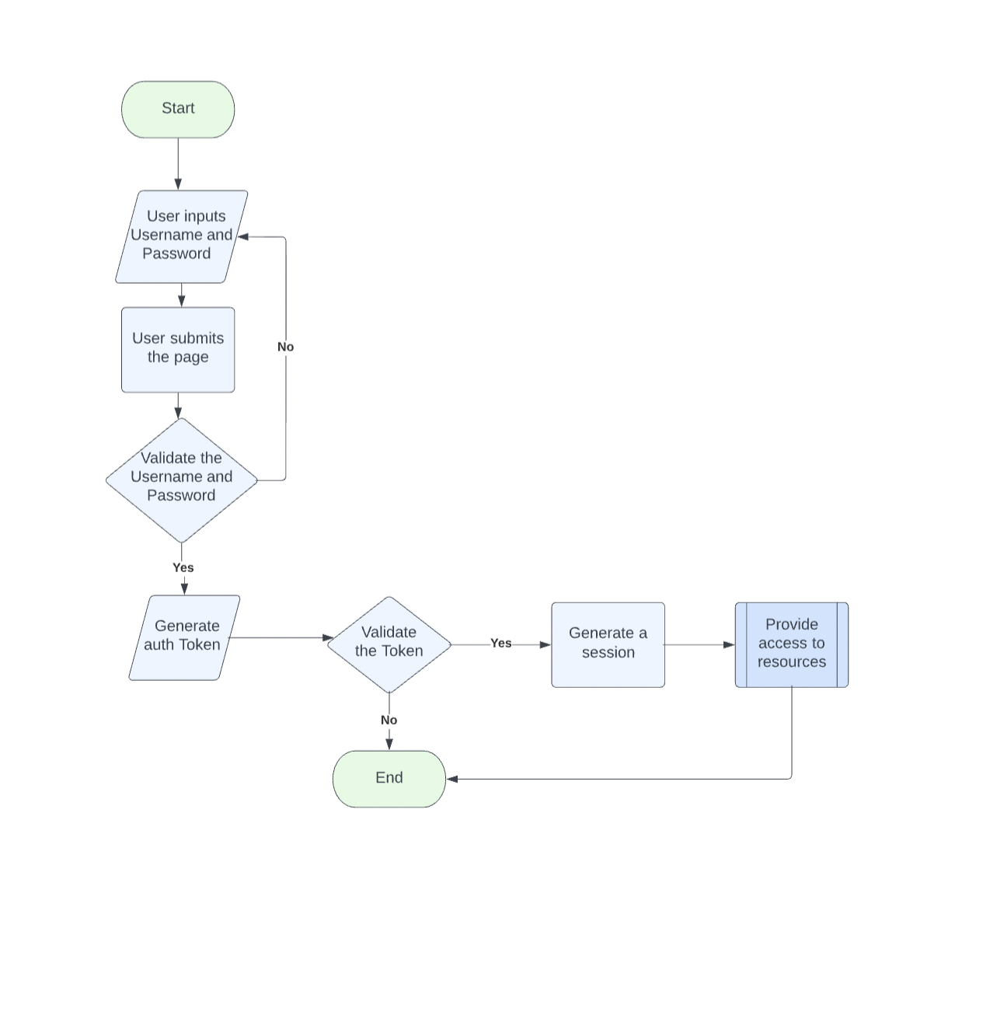

**4. Application Architecture:**

**Login Page:**

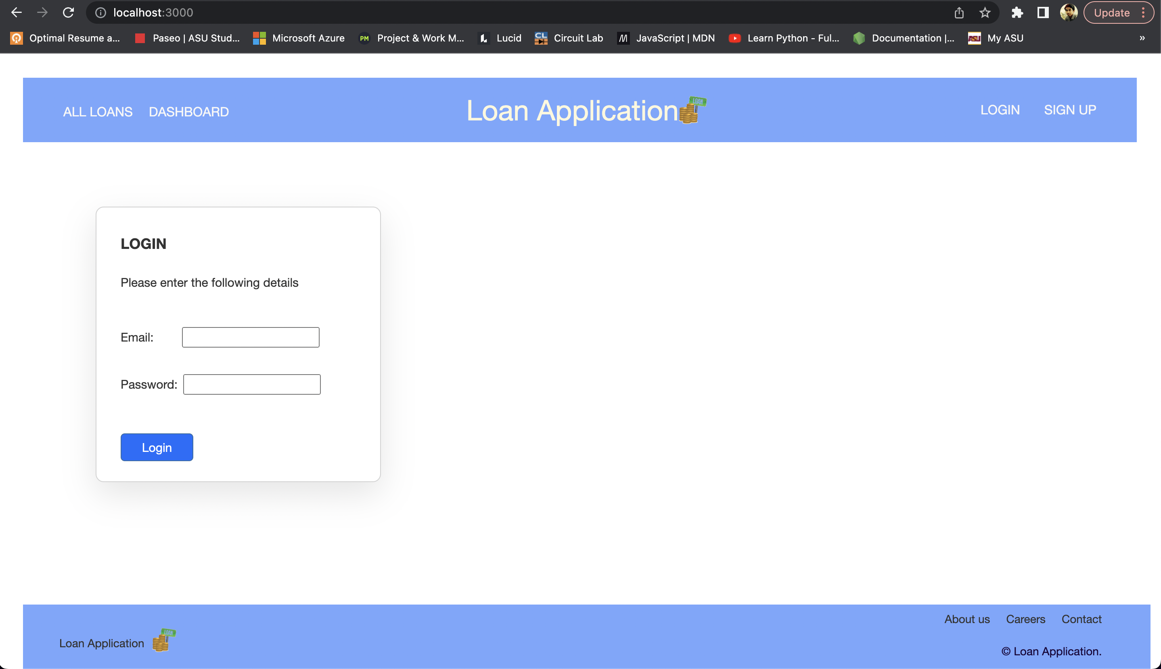

**Sign up page:**

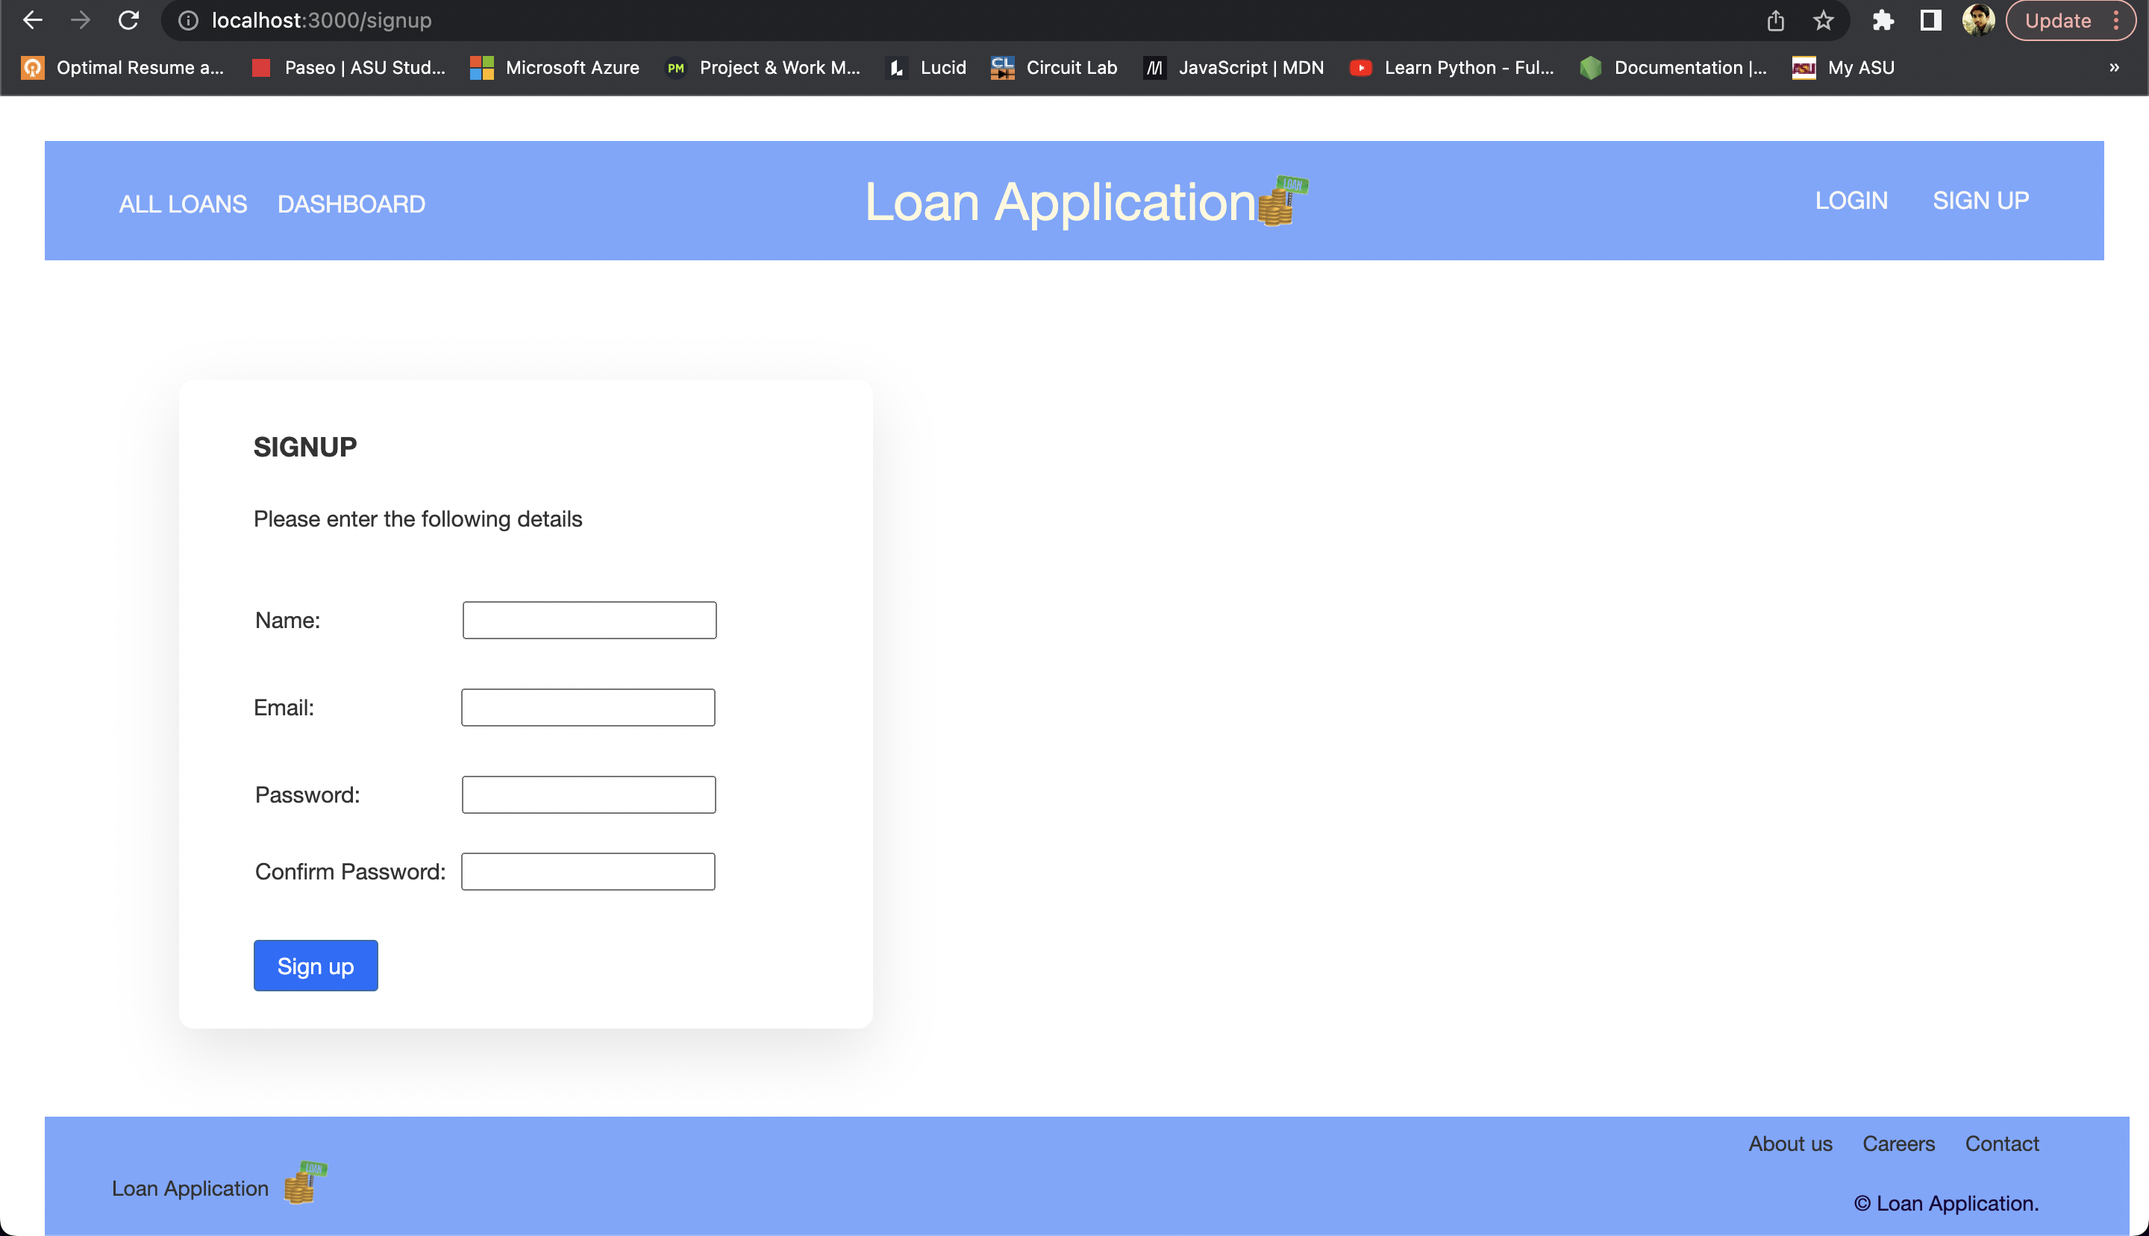

**Dashboard/Welcome Page:**

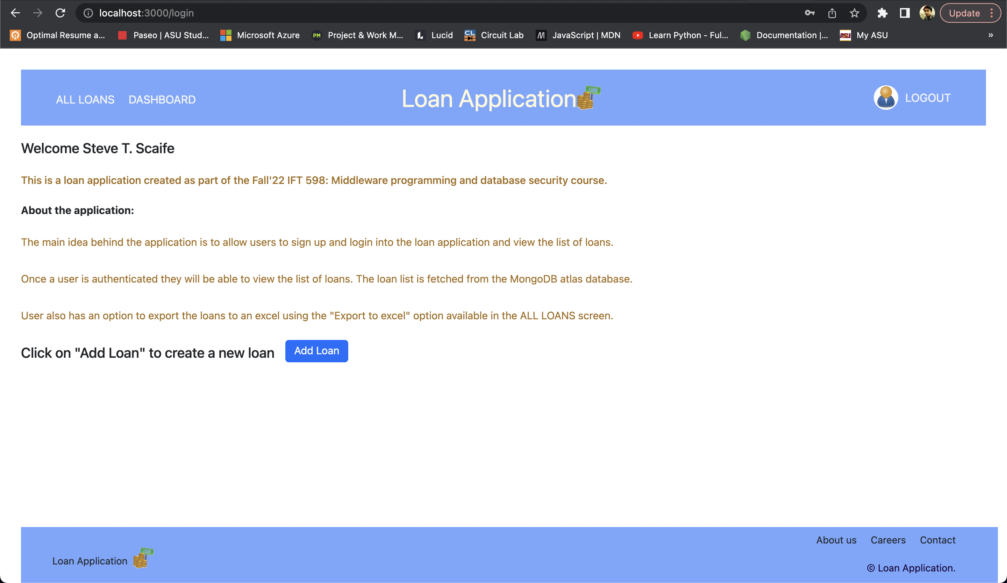

**Add Loans page:**

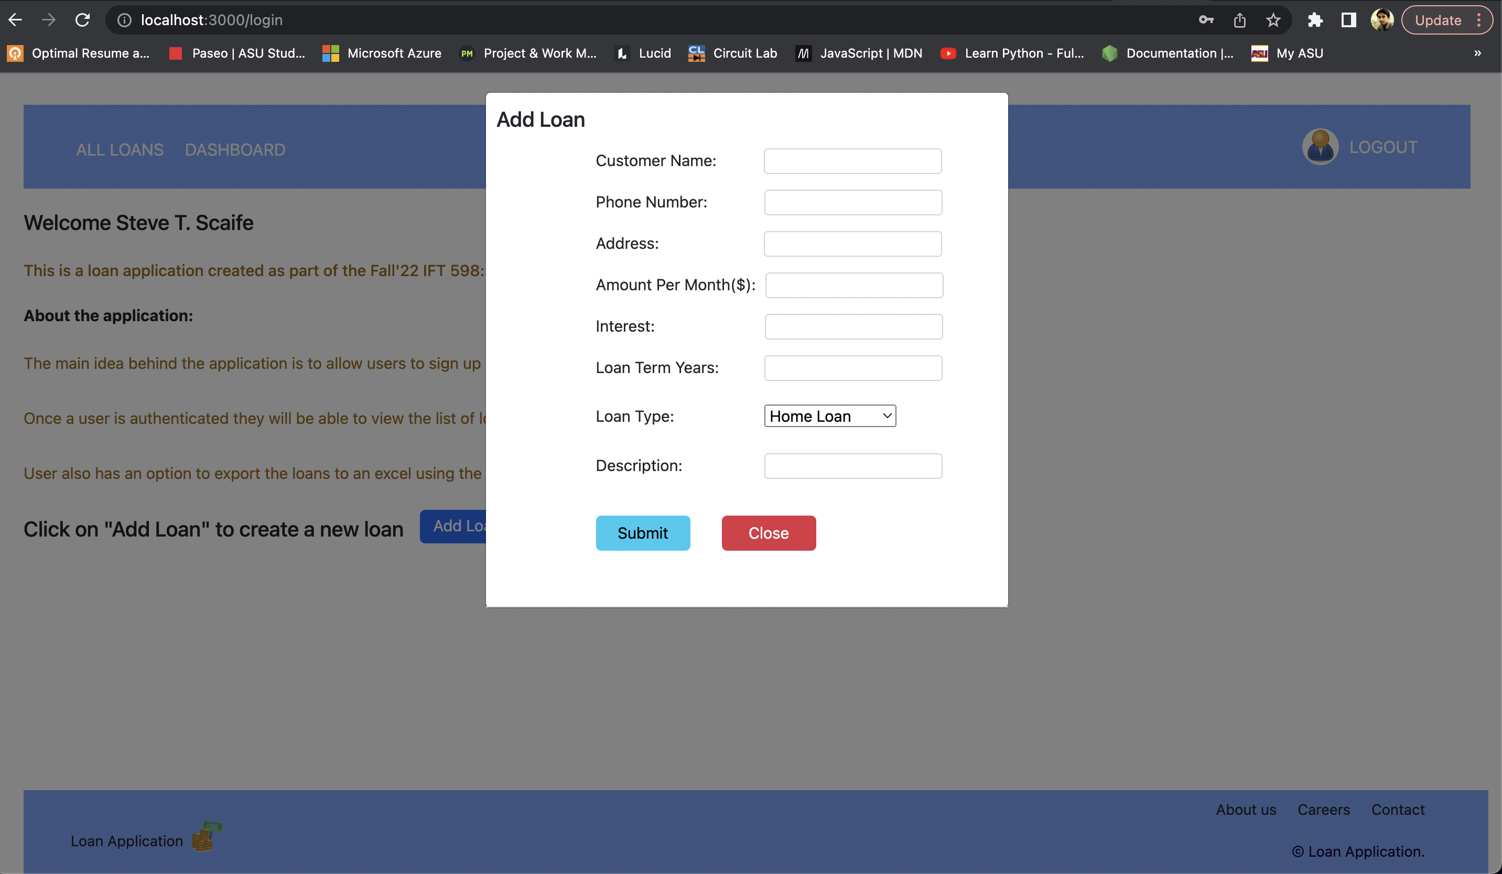

**All Loans Page:**

Users can export the loan data using the “Export to excel” option. Users can also sort the data and search specific data using the search feature.

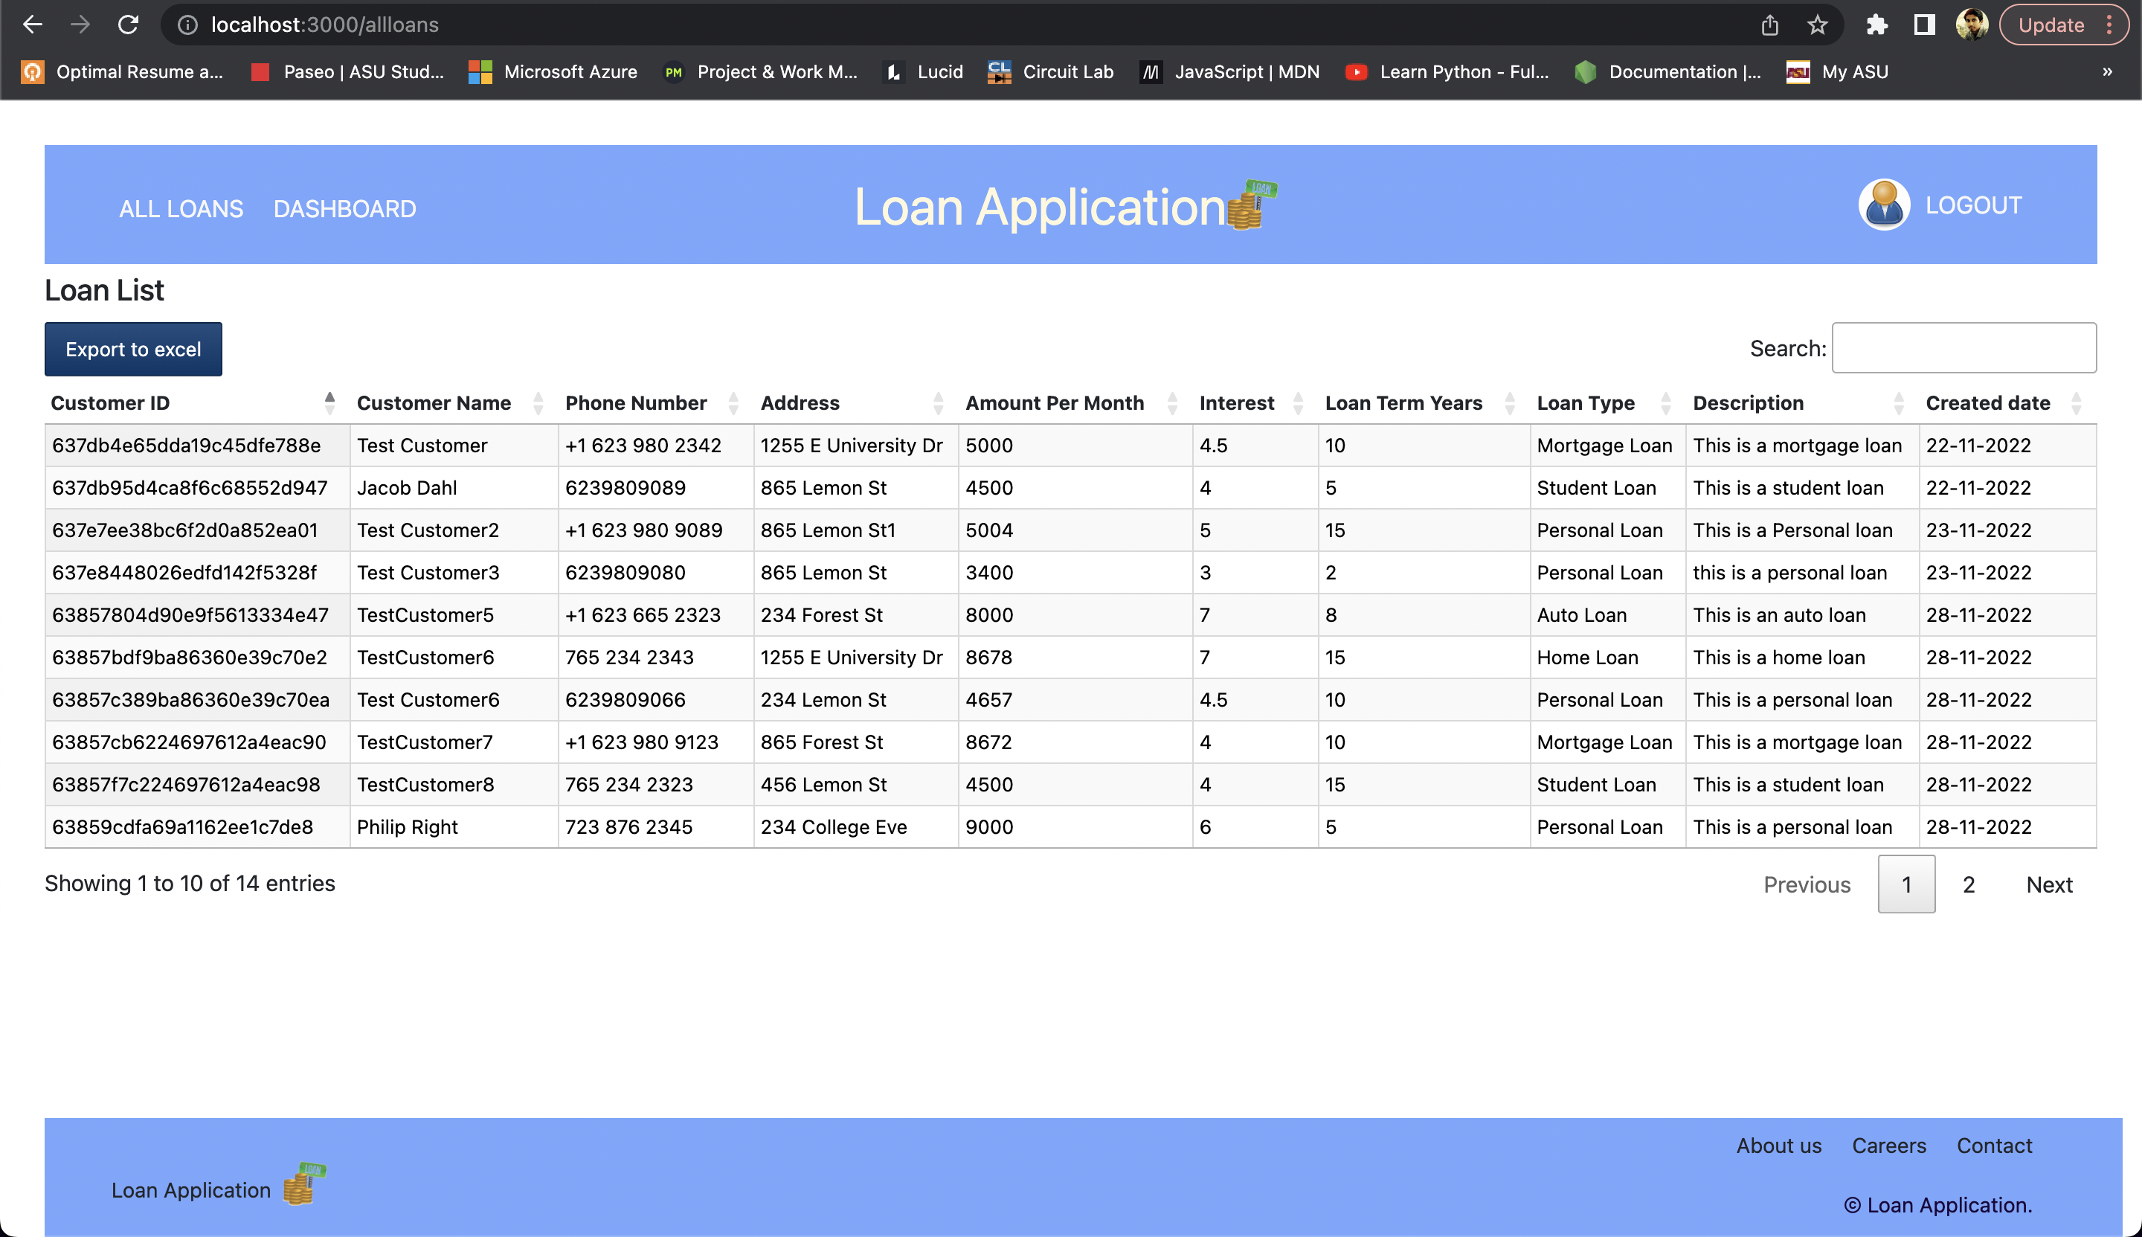

**Success alert on Logout:**

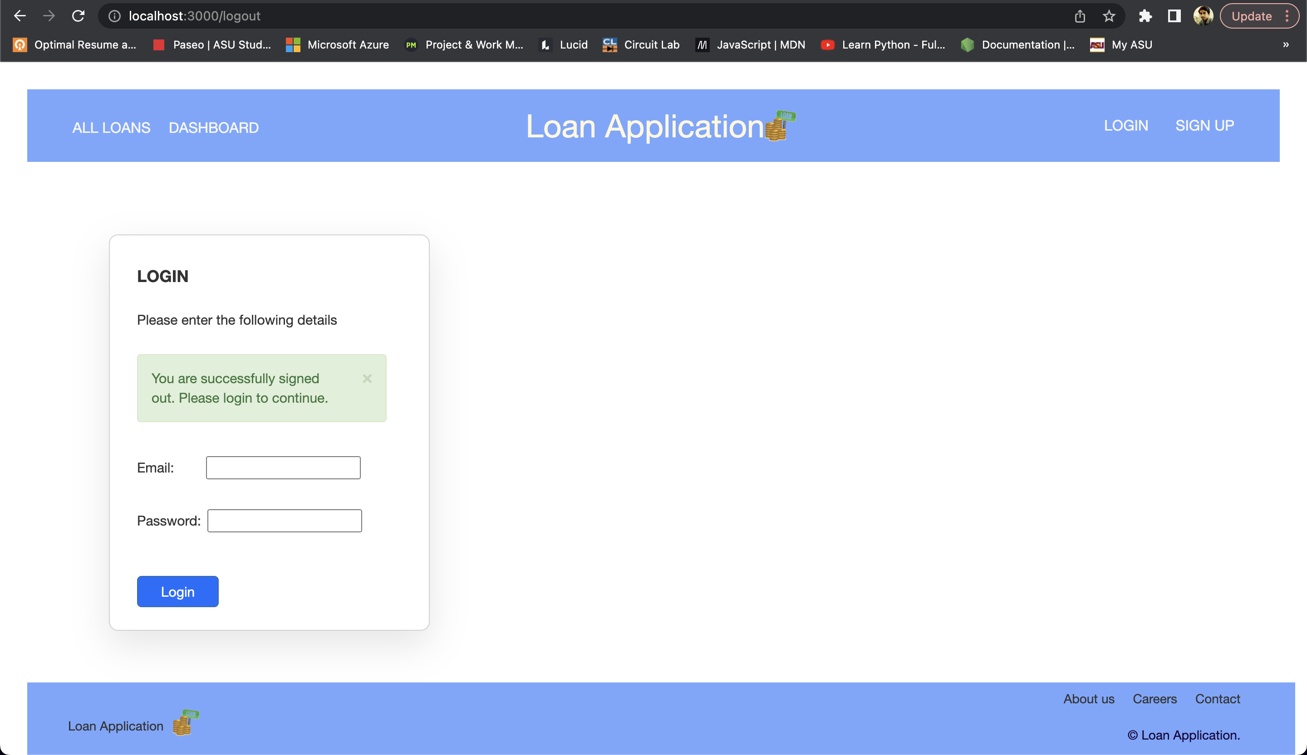

**Validation messages:**

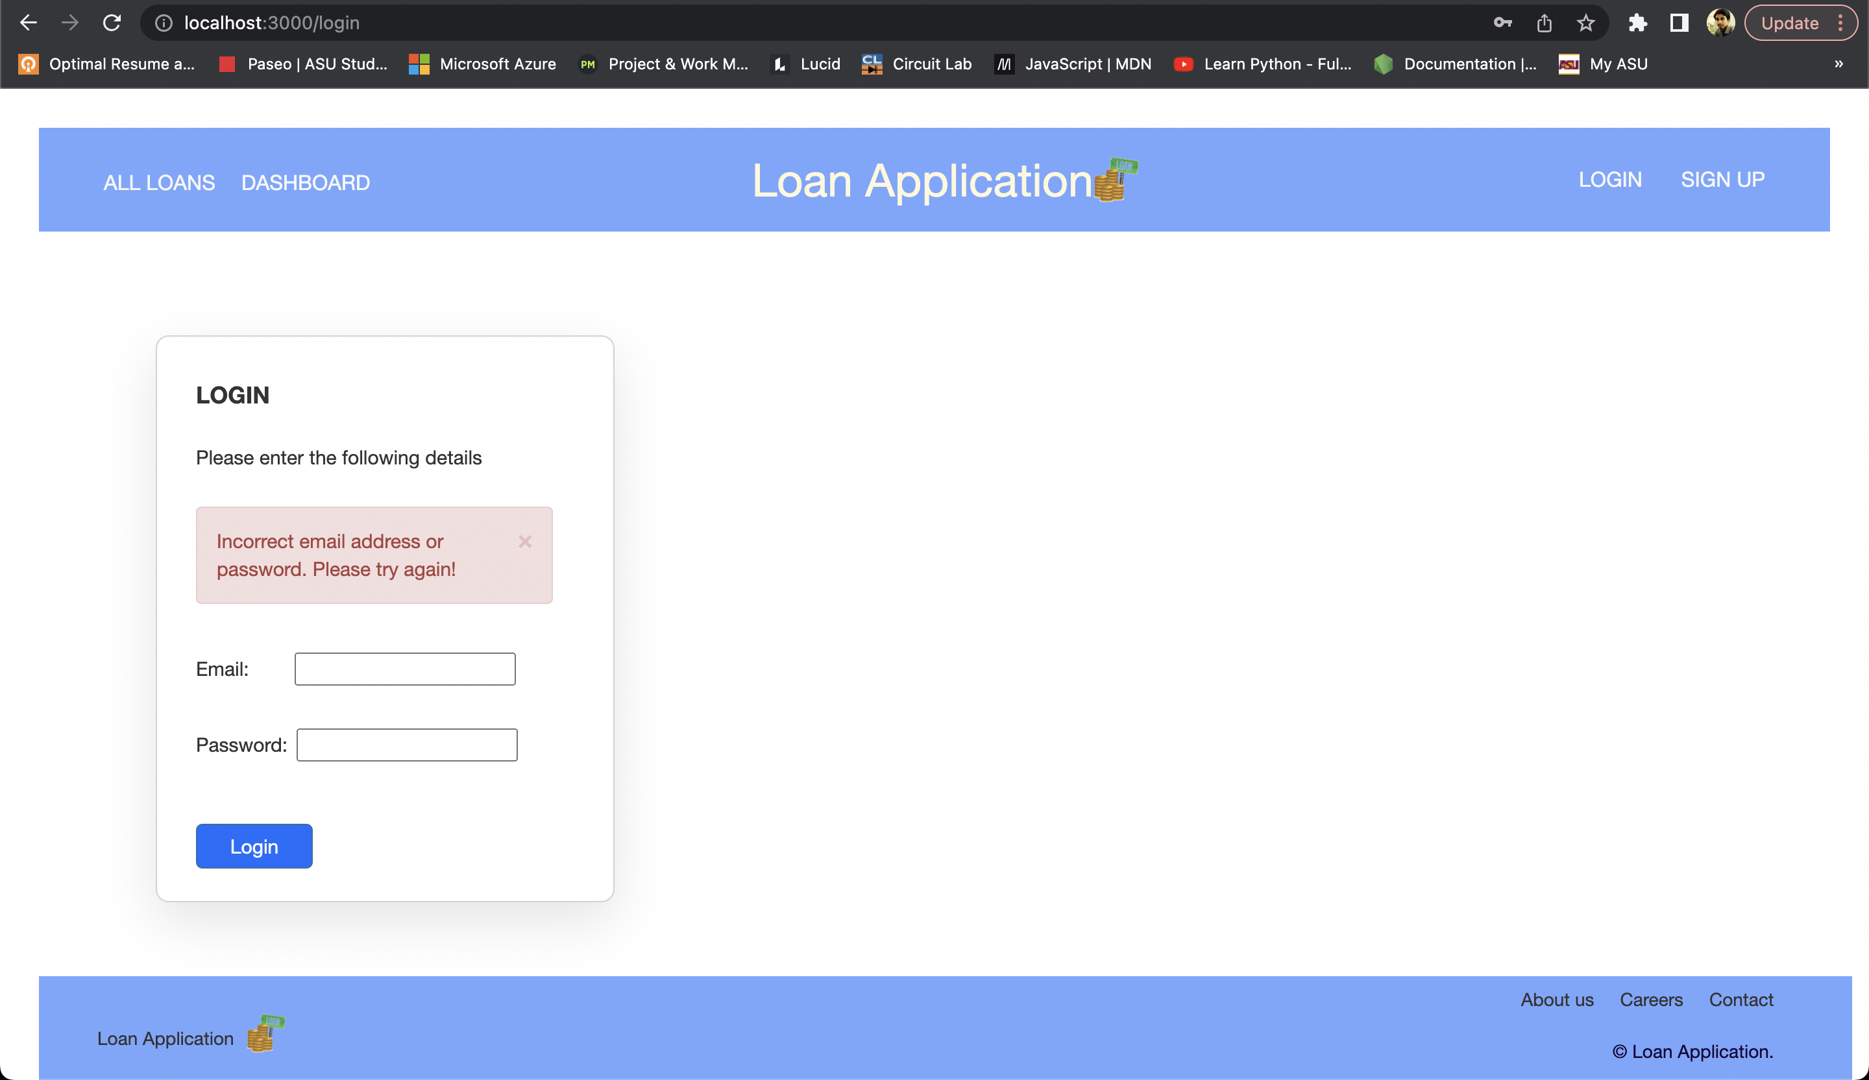

**Exported Excel Data:**

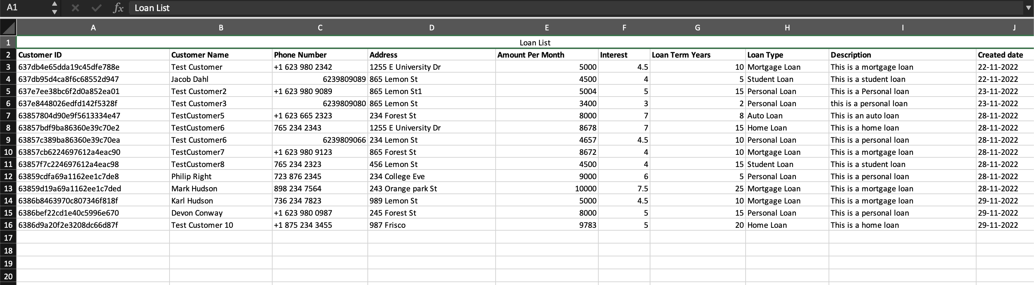

**Database Architecture:**

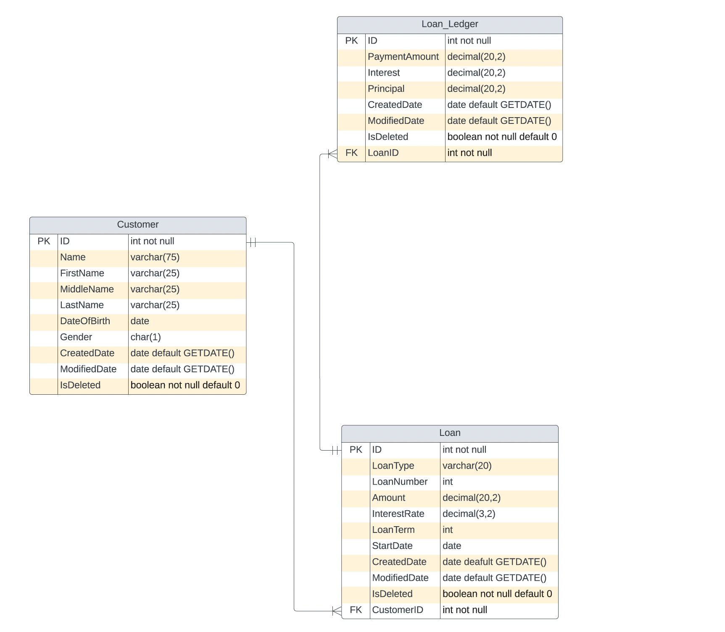

**Assumptions and Constraints:**

The loan application is developed with an assumption that there will not be any role-based access control. Every user who has access to the application will be able to create a new loan and access the list of loans.

**Future Enhancements:**

* Role based access control.
* Authentication using OAuth2.0
* Implementing forgot password feature.
* Editing and deleting a loan for admin.
* Including the technical design document within the application.